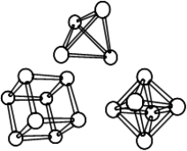
REGISTRATION FORM for
31st Slovenian-Croatian Crystallographic Meeting
Rogla, Slovenia, 18th – 22nd June 2025

ABSTRACT DETAILS
Name(s) of author(s)
Title of abstract
Time of presentation (10/15/20 min)
Presenting author
REGISTERED PARTICIPANT
Title
Name
Surname
Institution
Address
Phone
E-mail
Accompanying person(s)
I will attend the  conference trip (yes/no) |  | No. of persons:
I will take part at  the conference dinner (yes/no) |  | No. of persons:
I am applying for the 3D ED workshop (yes/no)*
* See additional information on the webpage.

Additional comments:

Please send this form via e-mail by 15th May 2025 to: sccm2025@fkkt.uni-lj.si

